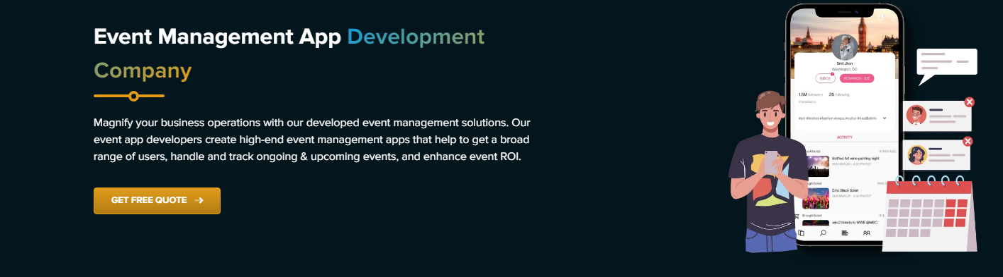**Event Management App Development Company**

We at IMG Global Infotech, a leading event management app development company, are committed to revolutionizing how events are organized and carried out. Connect with us and get industry-best event management app development services right away!

**\*\*\*\*\*\*\*\*\*\*\*\*\*\*\*\*\*\*\*\*\*\*\*\*\*\*\*\*\*\*\*\*\*\*\*\*\*\*\*\*\*\*\*\*\*\*\*\*\*\*\*\*\*\*\*\*\*\*\*\*\*\*\*\*\*\*\*\*\***

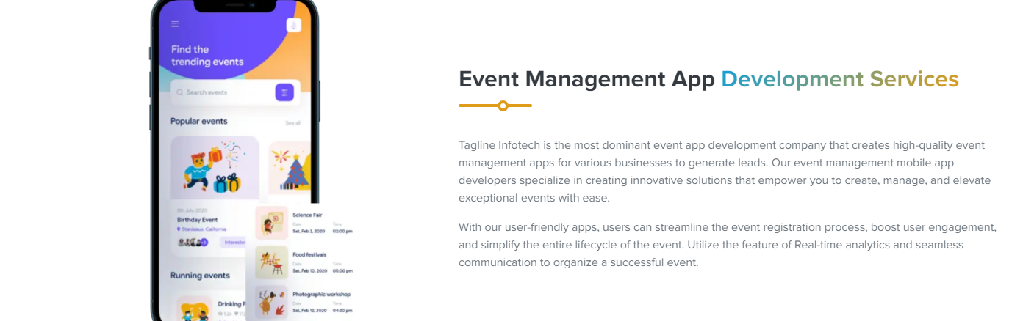

## **Event Management App Development Services**

At IMG Global Infotech, our event management app development services are made to make event preparation easier, increase productivity, and improve attendees' experience.

IMG Global Infotech believes in pushing the boundaries of event management app development with inventiveness and originality. Our knowledgeable team uses cutting-edge technology to develop event management apps that optimize event planning, promote smooth communication, and offer real-time updates.

Put your trust in IMG Global Infotech to deliver exceptional event management app development services, clearing the path for events that are memorable, flawlessly performed, and unforgettable. With us, you can enhance your event experience since we are committed to greatness and don't just guarantee it.

******************************************************************

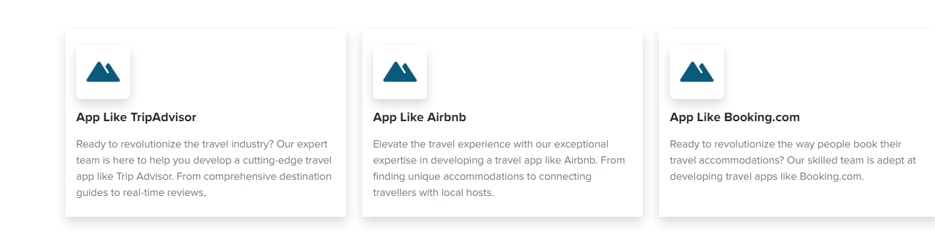

1. **App Like Eventbrite**

With your personalized event platform, you can explore an infinite world of possibilities. Imagine building a digital world where experiences are shared, connections are made, and dreams come true. We can create a distinctively yours app like Eventbrite using our expertise and your vision. Together, let's transform your concepts into unique events that are "your event, your way.

1. **App Like Monday.com**

Are you prepared to realize your dream of event management? Inspired by the adaptability and modern style of Monday.com, let's create an app unlike any other. Easily handle all facets of your events with just one app, including scheduling and guest lists. Your ideal event management app development will guarantee that your events are remembered as a shining example of effectiveness and innovation. Together, let's go out on this thrilling adventure!

1. **App Like Luma**

Are you prepared to build a cutting-edge event management application that can compete with Luma's genius? Together, we can create a digital masterpiece that combines beautiful design, easy event planning, and a user-friendly interface. We'll completely rethink event planning and take it to the next level. Are you prepared to achieve your goals and shine brightly like Luma? Together, let's start event management app development of the future.

******************************************************************

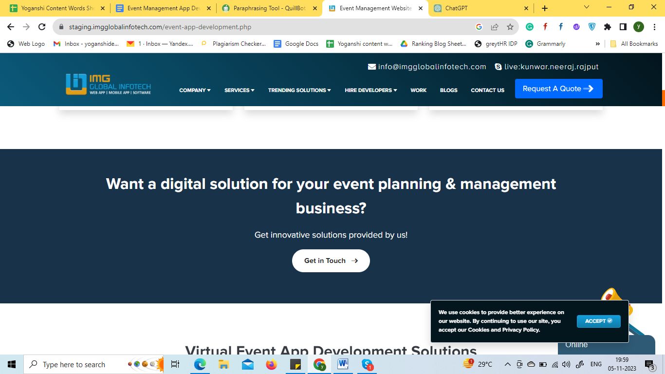

## **Do You Want To Build An Event Management App Software Development Solution?**

Get you own app like Everbrite in few weeks by connecting with our experts.

|  |
| --- |
| **Build An App Now!** |

******************************************************************

## 

## **Why Should Businesses Opt for Event Management App Development Today?**

1. **Efficient Planning and Organization:**

All event planning stages—from original conception to final execution—are streamlined by event management software. Business owners can use these applications to manage deadlines, assign projects, and coordinate teamwork effectively. By utilizing functionality such as task assignment capabilities, linked calendars, and real-time updates, enterprises can guarantee that their activities are well-organized.

1. **Enhanced Attendee Engagement:**

Contemporary customers look for captivating and immersive experiences. Event management applications enable enterprises to augment participant involvement before, throughout, and following events. Connectivity is fostered by features like interactive maps, real-time notifications, and customizable timetables that keep participants informed and engaged.

1. **Data-Driven Decision Making:**

Apps for event management produce valuable data that may be examined to help with decision-making. Businesses can learn more about the efficacy of their events by monitoring their attendees' behavior, preferences, and engagement data. With the use of data, organizations may make ongoing improvements to existing event strategies and future projects.

1. **Cost Savings and Resource Optimization:**

Conventional event preparation typically entails a large amount of paperwork and manual labor. Many of these duties are automated by event management programs, which minimizes the chance of mistakes and the requirement for extra work. This automation reduces operating expenses in addition to saving time. Businesses can also better utilize their resources by assigning employees to more strategic jobs.

1. **Accessibility and Global Reach:**

Businesses no longer have to limit themselves to local markets in an interconnected globe. Businesses may reach a worldwide audience by organizing virtual or hybrid events through event management applications. This broader reach makes new avenues for networking, brand exposure, and market expansion possible. Virtual events are more accessible and may suit a wider range of schedules and geographic constraints.

**\*\*\*\*\*\*\*\*\*\*\*\*\*\*\*\*\*\*\*\*\*\*\*\*\*\*\*\*\*\*\*\*\*\*\*\*\*\*\*\*\*\*\*\*\*\*\*\*\*\*\*\*\*\*\*\*\*\*\*\*\*\*\*\***

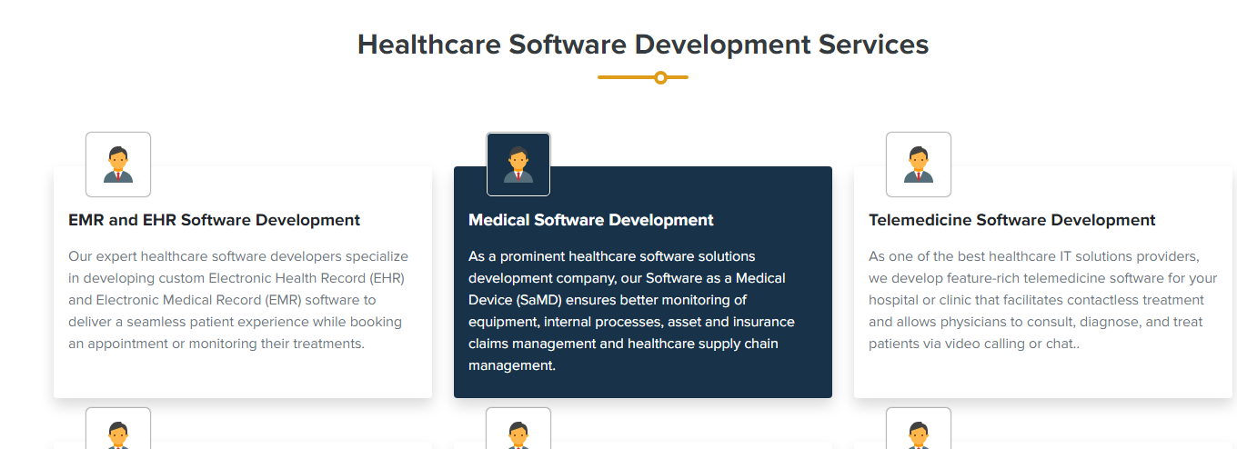

## **Event Management App Development Services**

1. **Mobile & Web Event Management App**

We at IMG Global Infotech are experts at providing cutting-edge services for mobile and web event management apps. Our solutions are painstakingly designed to optimize event planning and implementation, giving smooth experiences for planners and guests.

1. **Event Management App Consultation**

We provide knowledgeable Event Management App Consultation services. Our team helps clients who want to create innovative event management solutions by offering strategic counsel and wise direction. We guide clients through app development challenges with an emphasis on innovation and industry best practices.

1. **Custom Event Management App**

We specializes in delivering unparalleled Custom Event Management App services. Our solutions are meticulously crafted to meet the unique requirements of businesses. With a focus on innovation and user-centric design, we ensure seamless and efficient event planning via custom-developed applications.

1. **Event Ticket Management App**

Our team specializes in crafting cutting-edge Event Ticket Management Apps. Our services empower clients to seamlessly streamline ticket sales, registration, and check-in processes. With a user-friendly interface and robust features, our apps enhance the overall event experience. Trust IMG Global Infotech for innovative solutions.

1. **Hire Event Management App Developers**

We provide dedicated Event Management App Developers for hire. Our professionals have the skills and experience to craft innovative and customized solutions tailored to your specific event management needs. Choose IMG Global Infotech for top-tier development services elevating your event management capabilities.

1. **Event Management App Maintenance**

Get meticulous Event Management App Maintenance services from IMG Global Infotech. Our dedicated team ensures the seamless functioning of your app via regular updates, bug fixes, and performance enhancements. With a commitment to excellence, we offer ongoing support to keep your event management app running.

**************************************************************************************************

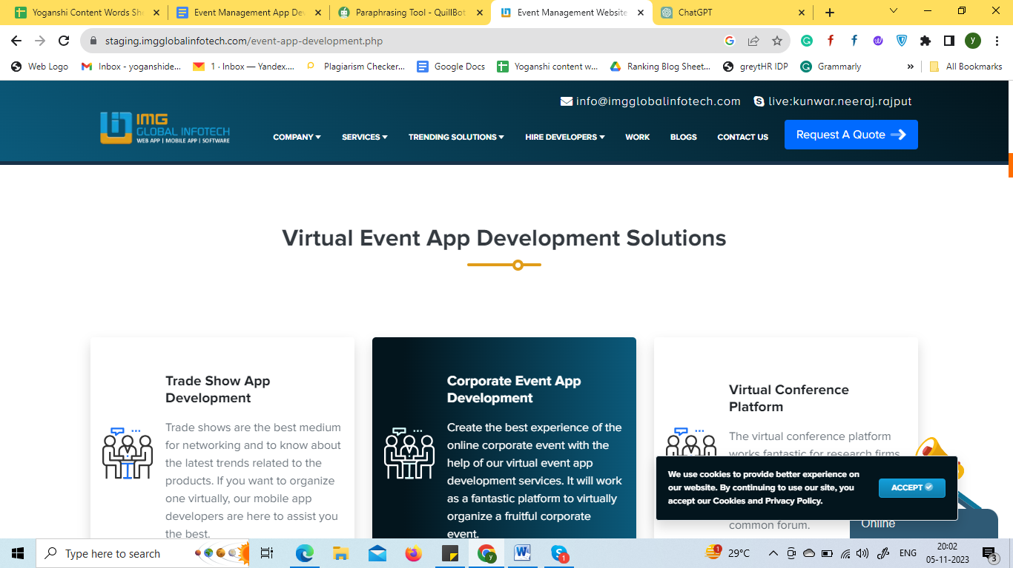

## **Event Management App Development Solutions**

1. **Event Networking Apps**

Use our Event Networking App to experience seamless networking! Make the most of your events, establish meaningful relationships, and easily connect. Simplify networking and make each attendee's experience one to remember.

|  |  |  |
| --- | --- | --- |
| Seamless Registration | Smart Matchmaking | Real-time Messaging |
| Interactive Agendas | Virtual Networking Spaces | Attendee Analytics |

1. **Trade Show and Expo Apps**

Examine our incredibly designed Expo and Trade Show Apps, created to improve your event experience. Access real-time timetables, interact with exhibitors, and browse exhibitions with ease.

|  |  |  |
| --- | --- | --- |
| Booth Reservation System | Interactive Floor Maps | Attendee Networking Tools |
| Event Schedule and Reminders | Live Streaming and Virtual Participation | Lead Retrieval and Analytics |

1. **Ticketing and Registration Apps**

With the help of our registration and ticketing apps, enjoy smooth event experiences. Simplify the procedure, boost participation, and guarantee hassle-free events. We've got you covered for a smooth event experience, from buying tickets to attendee registration.

|  |  |  |
| --- | --- | --- |
| Online Registration | Secure Payment Processing | Customizable Ticket Types |
| QR Code Integration | Real-time Analytics | Attendee Communication Tools |

1. **Event Marketing Apps**

Utilize the most advanced event marketing apps to elevate your events. Organize promotions with ease, interact with guests, and monitor success indicators. Boost event success with user-friendly features for optimal effect.

|  |  |  |
| --- | --- | --- |
| Targeted Audience Segmentation | Real-time Analytics and Reporting | Social Media Integration |
| Email Campaign Management | Customizable Event Pages | Attendee Engagement Tools |

1. **Corporate Event Management App**

Plan, coordinate, and carry out successful events with ease. Simplify communication, handle logistics, and improve teamwork. Enhance your business meetings with our intuitive and effective platform.

|  |  |  |
| --- | --- | --- |
| Seamless Registration and RSVP Tracking | Dynamic Agenda and Schedule Management | Real-time Communication Tools |
| Vendor and Venue Management | Attendee Networking and Engagement Features | Analytics and Reporting Capabilities |

1. **Social Event Planning App**

Coordinate details with ease, handle guest lists, and plan events with ease. Improve the experience of organizing events with simple-to-use features that make social event planning a snap.

|  |  |  |
| --- | --- | --- |
| Seamless Guest List Management | Intuitive RSVP Tracking | Dynamic Event Scheduling |
| Collaborative Planning Tools | Customizable Invitations | Real-time Communication Hub |

**\*\*\*\*\*\*\*\*\*\*\*\*\*\*\*\*\*\*\*\*\*\*\*\*\*\*\*\*\*\*\*\*\*\*\*\*\*\*\*\*\*\*\*\*\*\*\*\*\*\*\*\*\*\*\*\*\*\*\*\*\*\*\*\*\*\*\*\*\***

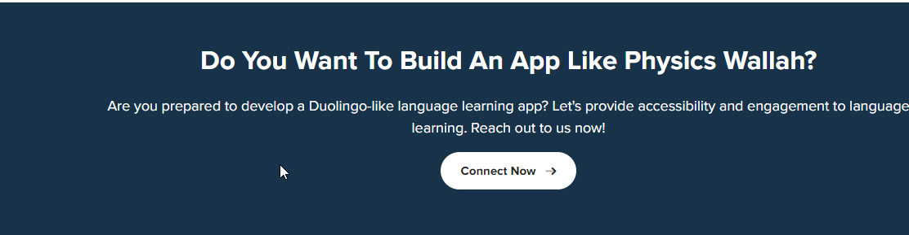

## **Are You Interested In Creating An Event Management App?**

Would you like to create an app for event management? With simple-to-use tools, you can easily coordinate events and create memorable experiences.

|  |
| --- |
| **Connect Now!** |

**\*\*\*\*\*\*\*\*\*\*\*\*\*\*\*\*\*\*\*\*\*\*\*\*\*\*\*\*\*\*\*\*\*\*\*\*\*\*\*\*\*\*\*\*\*\*\*\*\*\*\*\*\*\*\*\*\*\*\*\*\*\*\*\*\*\*\*\*\***

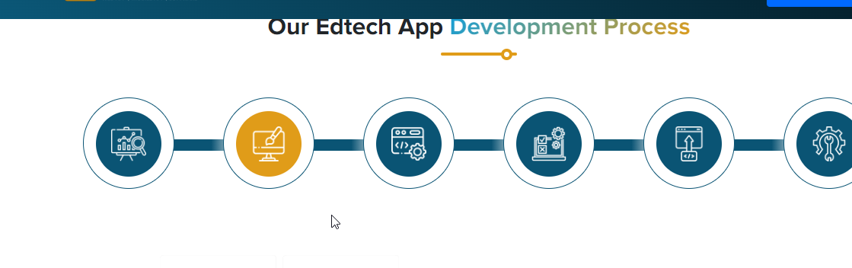

## **Our Event Management App Development Process**

1. **Planning**:

During this critical period, we work with our clients to comprehend their event management demands, objectives, and target audience. We establish the main features and functionalities of the app, create project milestones, and carry out in-depth market research.

1. **Designing:**

Equipped with a well-defined concept from the planning stage, our design team develops an aesthetically pleasing and intuitive user interface. We put the user experience first, ensuring the app is visually beautiful and simple to use. Prototypes and wireframes are designed to offer a concrete sneak peek into the appearance of the app.

1. **Development**:

It is vital to know that the actual coding of the application begins the development stage. Our development team builds a reliable and scalable event management app by utilizing the newest technologies. Regular communication is maintained to inform clients about the development status.

1. **Testing**

The most critical stage of development is testing. It is essential to learn that thorough testing is done to find and fix errors, malfunctions, or performance problems. To ensure the app satisfies the highest standards of functionality and dependability, our quality assurance team uses a variety of testing approaches.

1. **Deployment**:

It is the stage where the app can be deployed after it has passed rigorous testing and been approved by the client. It is crucial to remember that we have a dedicated team of developers that oversee the seamless transfer of the application from development to the live environment, ensuring that users can access and utilize it.

1. **Maintenance & Updates:**

We remain steadfast in our commitment even after the debut. We offer continuous upkeep and assistance to resolve any problems quickly. To keep the app up to date and competitive in the ever-changing field of event management technology, we also keep an eye on new developments and customer feedback.

**\*\*\*\*\*\*\*\*\*\*\*\*\*\*\*\*\*\*\*\*\*\*\*\*\*\*\*\*\*\*\*\*\*\*\*\*\*\*\*\*\*\*\*\*\*\*\*\*\*\*\*\*\*\*\*\*\*\*\*\*\*\*\*\*\*\*\*\*\***

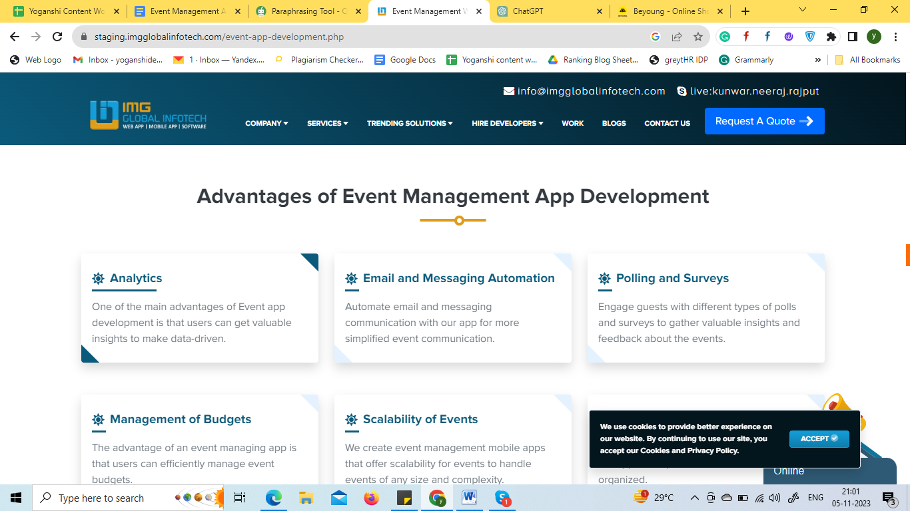

## **Advantages of Event Management App Development**

1. **Streamlined Planning and Organization:**

Event management app development make it easier to organize and schedule events. They offer resources for organizing and managing vendor contracts, guest lists, event schedules, and other important information.

1. **Enhanced Communication:**

Real-time contact between merchants, participants, and organizers is made possible by these event management app development. Alerts, messaging services, and push notifications keep all parties involved and informed.

1. **Ticketing and Registration:**

Integrated ticketing and registration features are standard in event management app development. With just a few clicks, attendees may purchase tickets, choose their preferred seating, and register for events.

1. **Improved Attendee Experience:**

Event applications give attendees access to vital information, improving their overall experience. Maps, speaker bios, exhibitor lists, and event schedules are all available for attendees to examine in one location.

1. **Data Analytics and Insights:**

These apps allow event planners to collect important information about attendees, like demographics, engagement metrics, and feedback. Future events can be improved continuously, with targeted marketing campaigns.

1. **Cost and Time Savings:**

The time and resources needed for manual processes like printing materials, managing paper registrations, and processing payments are significantly reduced with event management software.

*********************************************************************

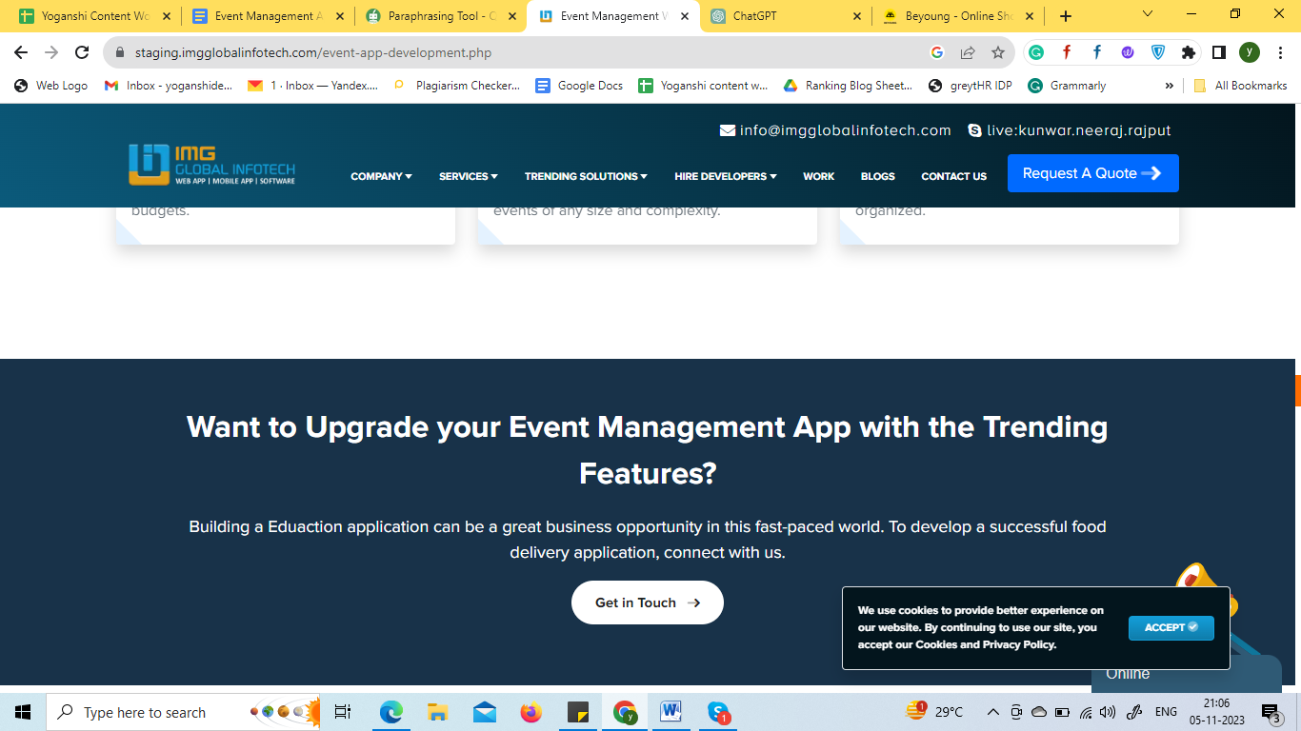

## **Know the Cost To Build An Event Management App At Afforadble Rates**

Are you prepared to realize your idea for an event management app? Get a free quotation immediately to learn how to create your ideal app at a reasonable cost. Don't pass up this chance to develop a state-of-the-art solution for your demands in event organizing.

|  |
| --- |
| **Get In Touch!** |

**\*\*\*\*\*\*\*\*\*\*\*\*\*\*\*\*\*\*\*\*\*\*\*\*\*\*\*\*\*\*\*\*\*\*\*\*\*\*\*\*\*\*\*\*\*\*\*\*\*\*\*\*\*\*\*\*\*\*\*\*\*\*\*\*\*\*\*\*\***

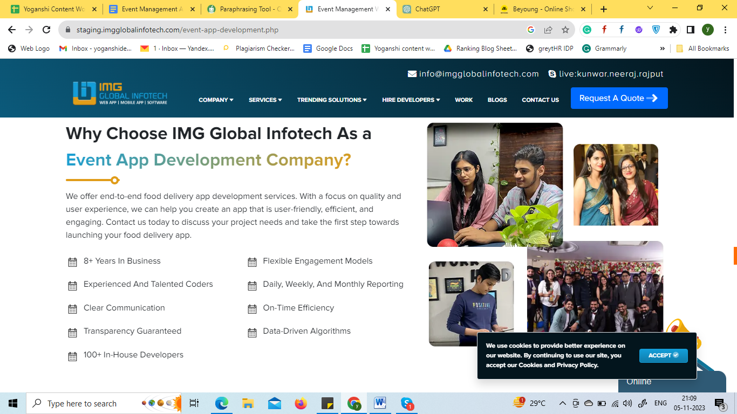

## **Why Choose IMG Global Infotech As a Event App Development Company?**

IMG Global Infotech's outstanding experience, creative ideas, and client-focused philosophy make them a standout option for event app development. IMG Global Infotech has a history of developing innovative event apps and provides customized solutions that improve user engagement, simplify event management, and provide flawless experiences. Our dedication to excellence, punctuality, and economy positions them as the go-to collaborator for developing event apps.

* 8+ Years In Business
* Experienced And Talented Coders
* Clear Communication
* Transparency Guaranteed
* 100+ In-House Developers
* Flexible Engagement Models
* Daily, Weekly, And Monthly Reporting
* On Time Efficiency
* Data-Driven Algorithms

**\*\*\*\*\*\*\*\*\*\*\*\*\*\*\*\*\*\*\*\*\*\*\*\*\*\*\*\*\*\*\*\*\*\*\*\*\*\*\*\*\*\*\*\*\*\*\*\*\*\*\*\*\*\*\*\*\*\*\*\*\*\*\*\*\*\*\*\*\***

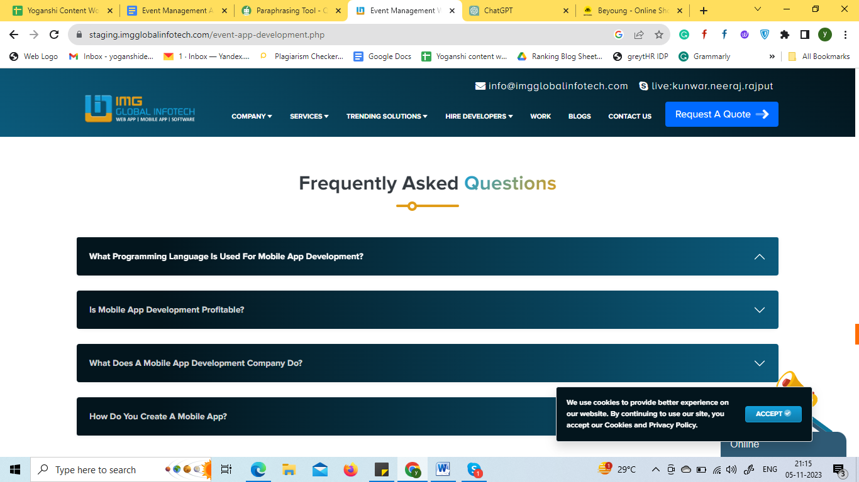

1. **How Much Does It Cost To Build An Event Management App?**

The cost of developing event management software might differ significantly depending on features, complexity, and the rates of the development team. More sophisticated apps can cost anywhere from $16,000 to $25,000 or more, while essential apps typically cost between $8,000 and $16,000.

1. **How Much Time Does It Take To Develop An App for Event Management?**

Depending on the complexity and functionality of the app, developing an event management app usually takes three to nine months.

1. **Why Choose IMG Global Infotech For Event Management App?**

IMG Global Infotech's skill, seasoned staff, and track record in the industry make it a viable option for developing event management apps. We can provide solutions that are specifically tailored to your needs.

1. **Do You Sign an NDA?**

Whether IMG Global Infotech executes a non-disclosure agreement (NDA) depends on your requirements and our rules. A lot of development firms are willing to sign NDAs to maintain the privacy of your app.

1. **Is It Profitable to Develop Mobile Apps?**

Profitable mobile app development is possible, but it depends on several variables, including market demand, software quality, marketing, and monetization techniques. Offering a distinctive and worthwhile solution can yield substantial profits, but to optimize profits, rigorous planning and study are necessary.